Git and Git Hub task - 02
========================================================================

- Install git.
- I have checked the version by using git --version

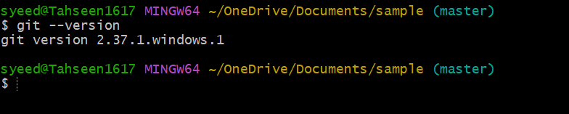

- Create a repo in github with README.md and .ignore file.
- In central repository I have created a repo and gave permission for Add README

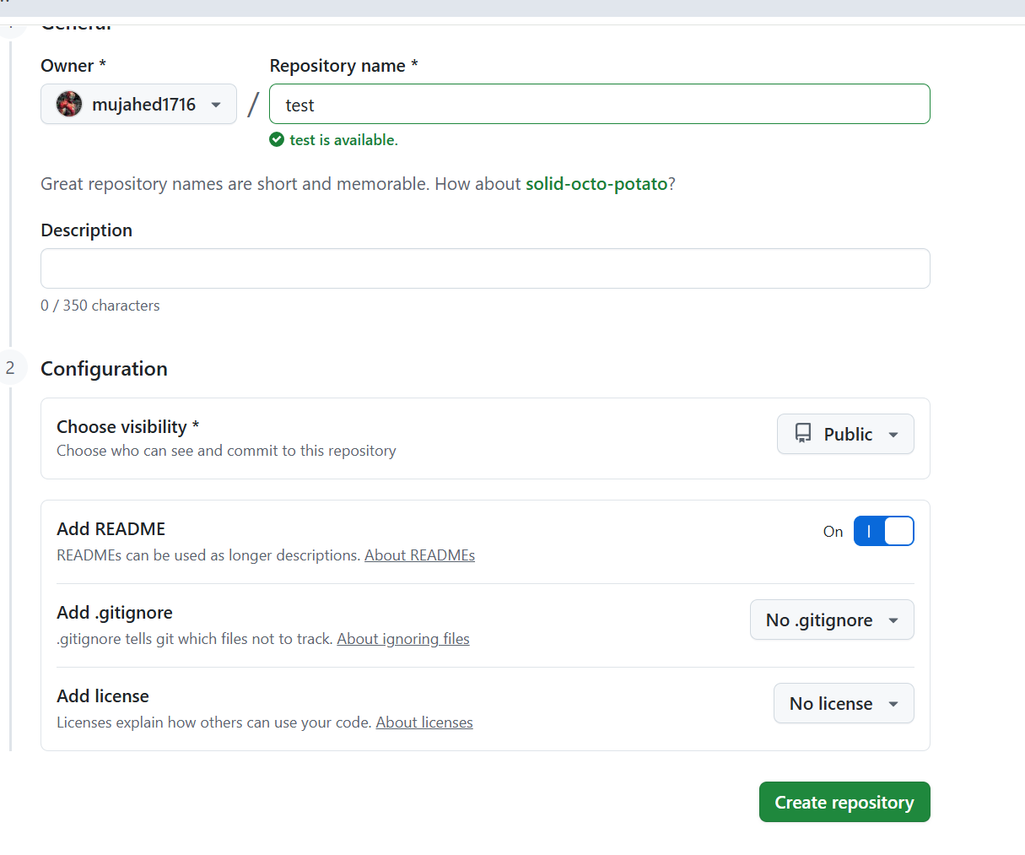

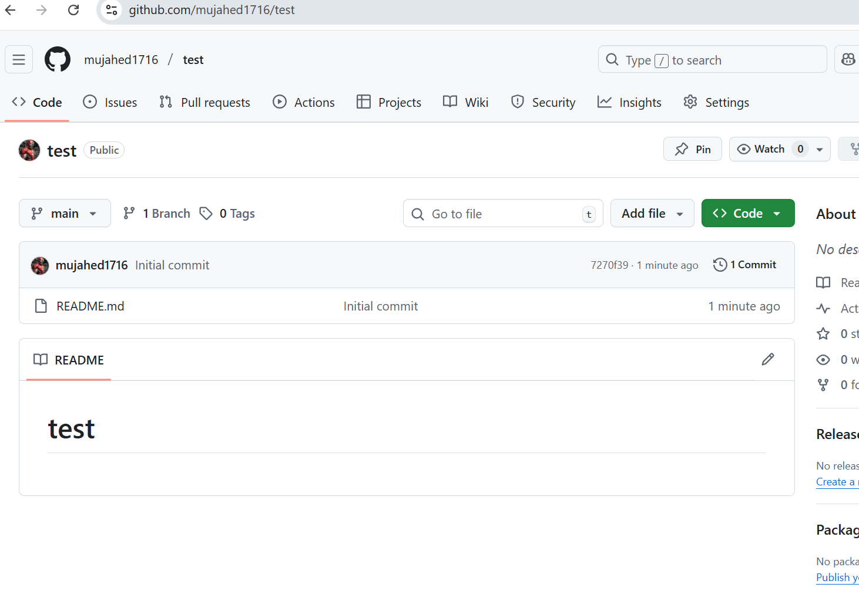

- Clone the created repo to local.

- I have cloned the central repo to local by using git clone and main url command

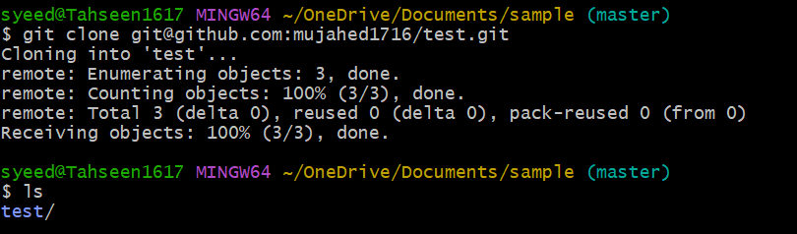

- Create two files in local repo.
- I have created two files in local repo by using touch command

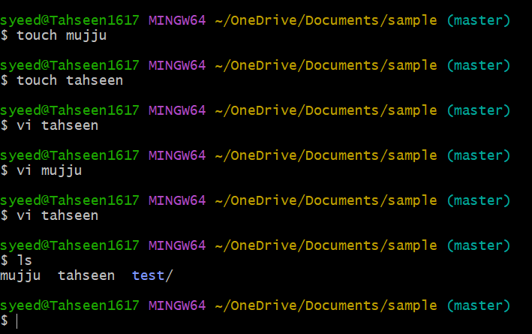

- Commit two files and push to central Repository.
- Here I have commited two files by using git command -m command and pushed into central repo by using git push -u origin main command

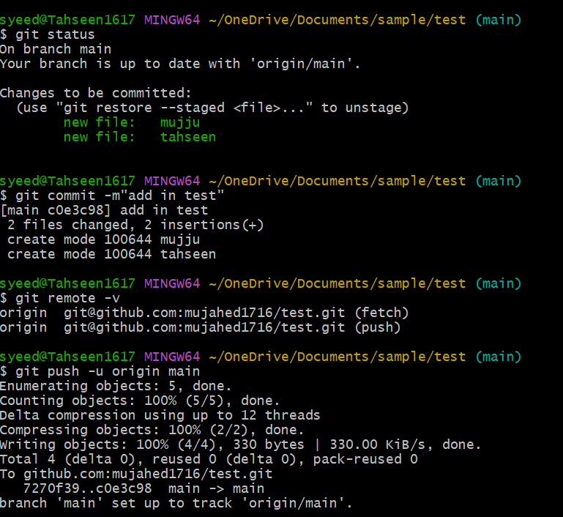

- Here I checked in central repository the two files were pushed
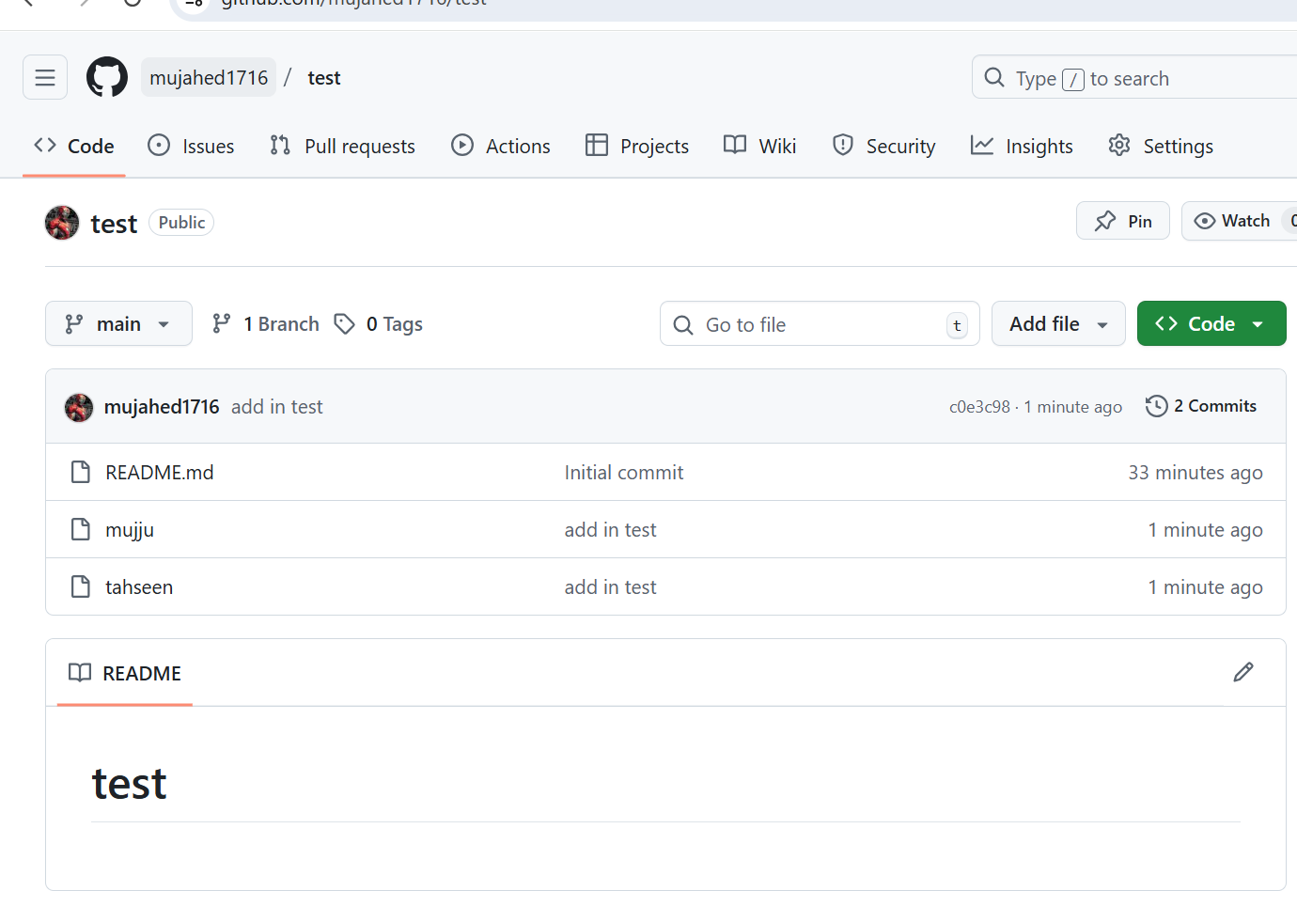

- Create a branch in local and create a sample file and push to central.
- I have created a branch in local repo by using git branch new branch name
- Created a sample file by using touch command
- Pushed it into central repository by using git push -u origin main
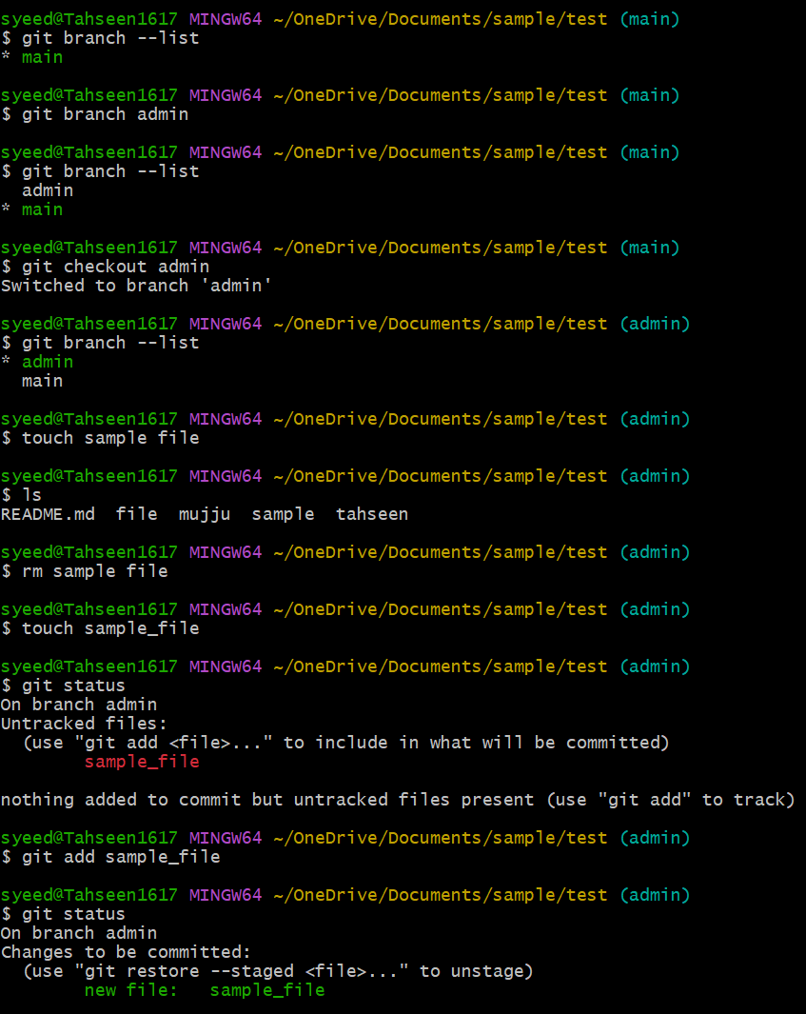

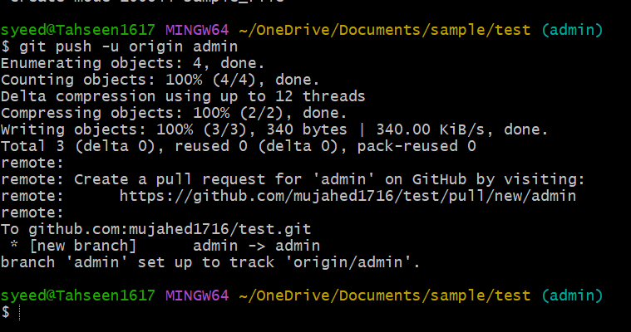

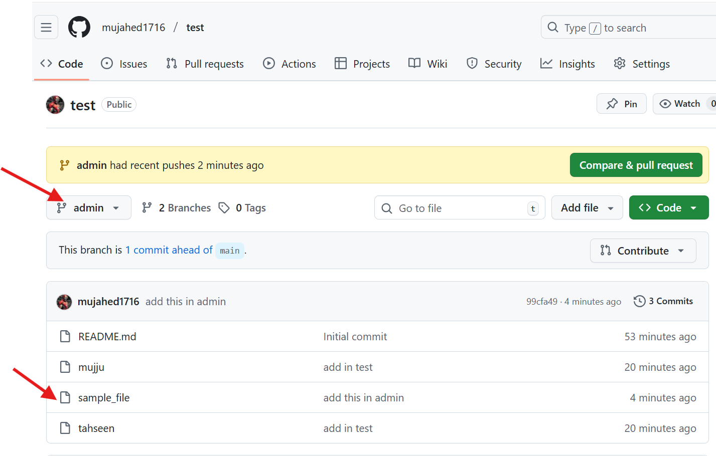

- Create a branch in github and clone that to local.
- I have created a branch in central repository
- I have used git pull command to download updated changes
- I have changed the branch to repo by using git checkout branch name

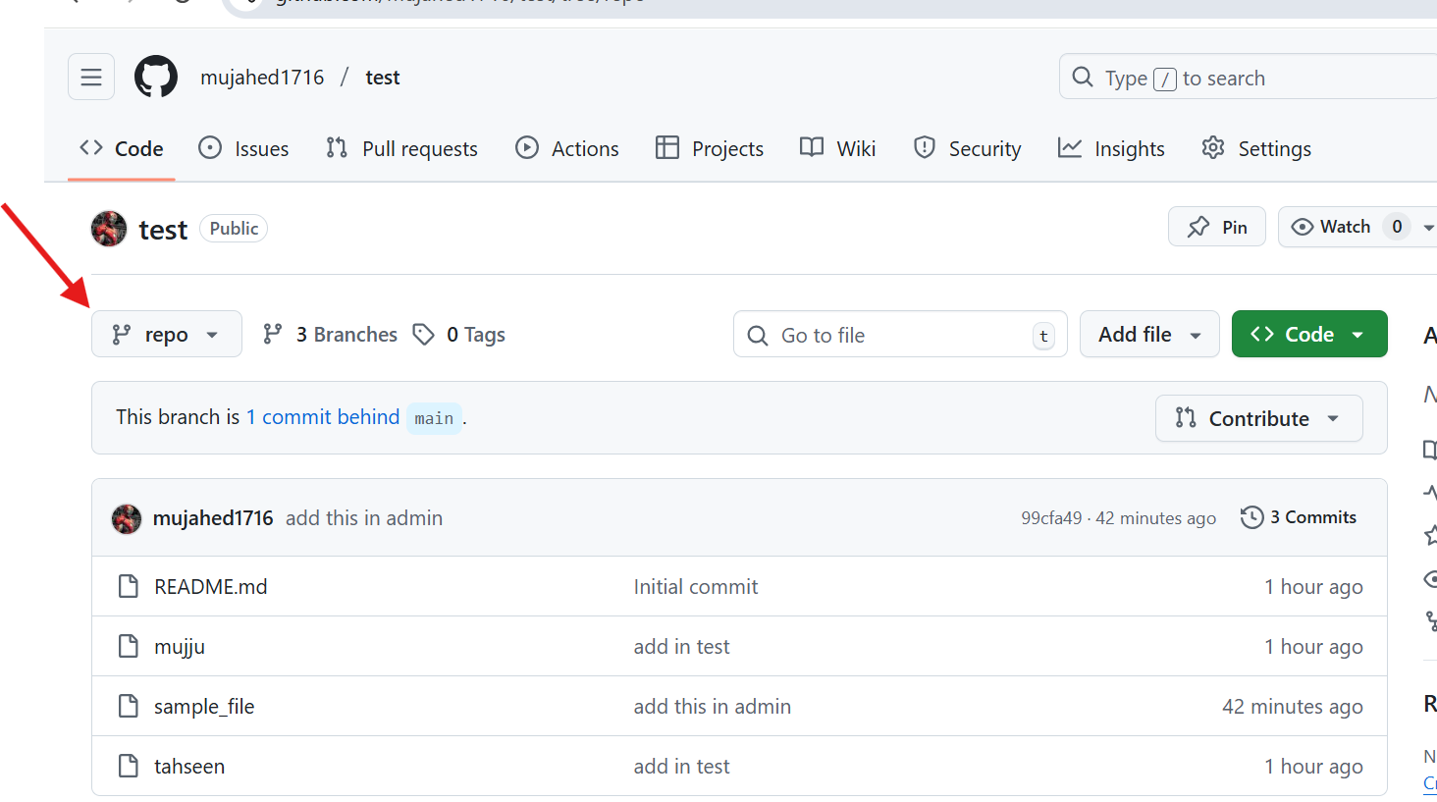
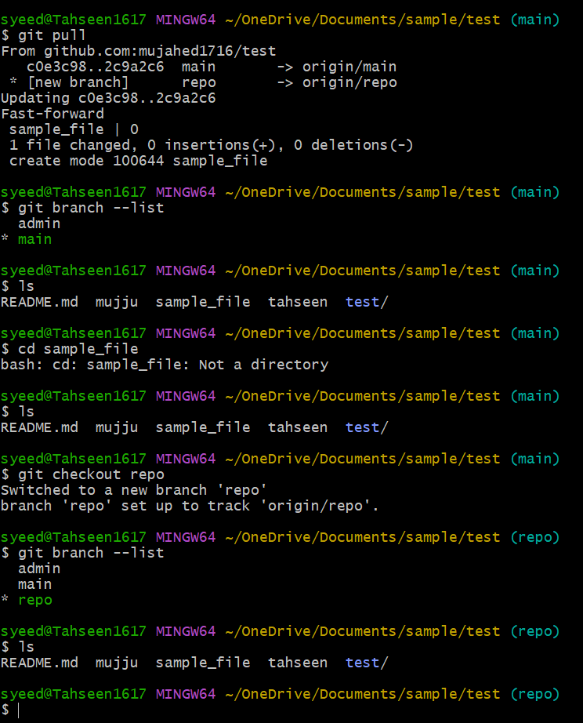

- Merge the created branch with master in git local.
- I have merged the created branch withy master by using git merge command
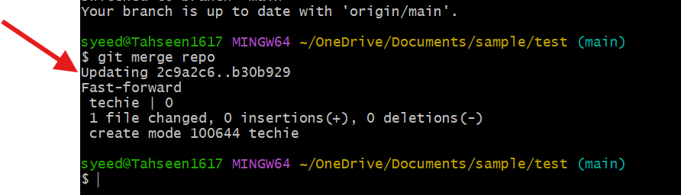

- Merge the created branch with master in github by sending a pull request.

- Here I have merged the created branch with master by sending a pull request and merging them
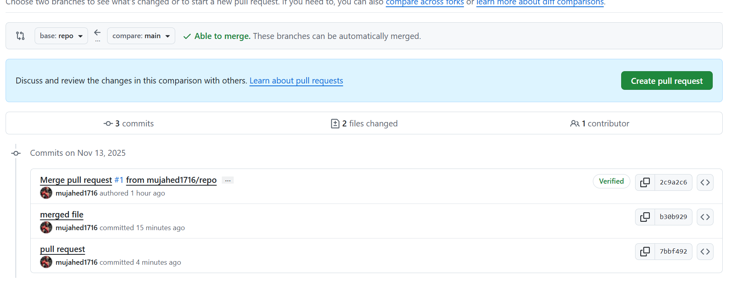

- Create a file in local and send that to branch in github.
- I have created a file named abc.txt and commited it and then sent to branch in github by using git push -u branch name command

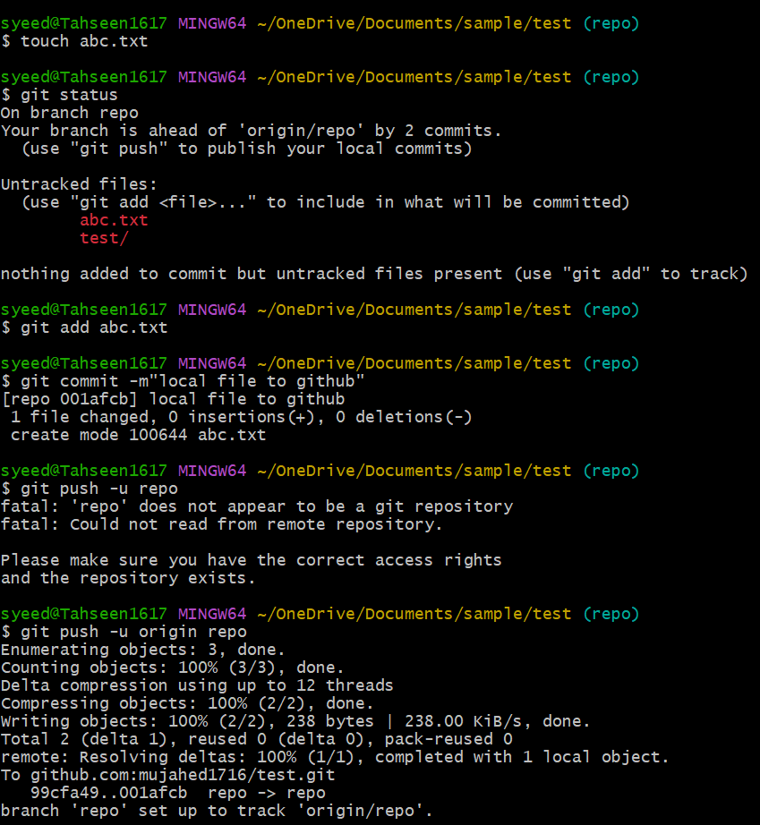

- Here is the proof

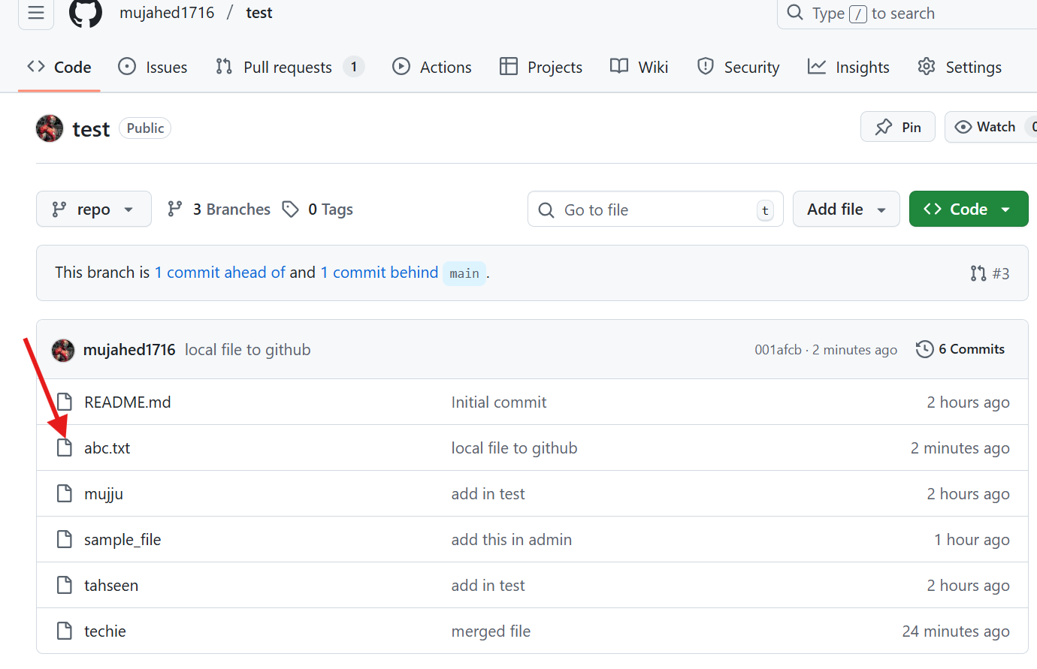

- Clone only a branch from github to local.
- I have cloned a single branch by using git clone –branch repo –single branch url command
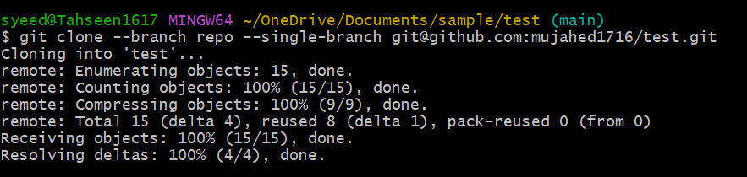

- Create a file with all passwords and make that untrackable with git.
- I have created a file by .gitignore name and added password in file and pushed it into central repository which can be seen only by me.
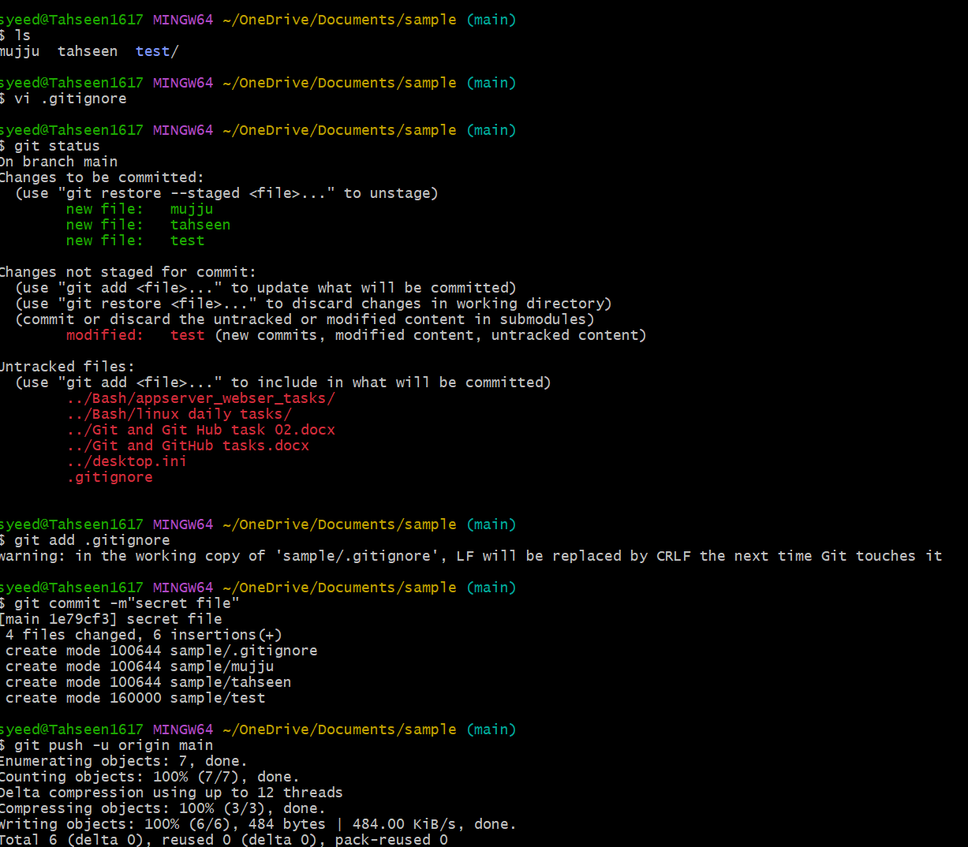
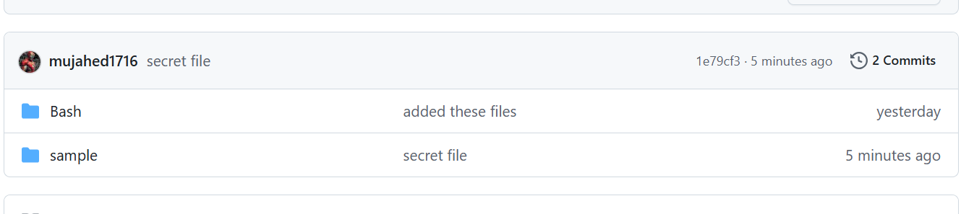

- Make a commit and make that commit reset without savings changes.
- I have made a commit and used the git reset command and again added into untracked list.
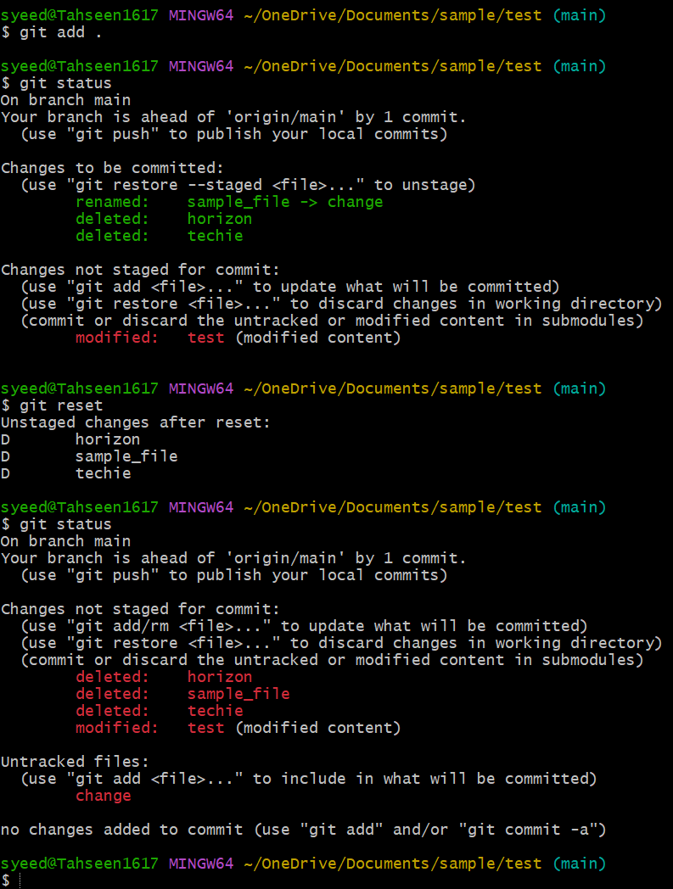

- Revert a commited commit to the older version.
- I have checked the logs by using git log command
- Then reverted it by using git revert and commit id and changed it to older version.
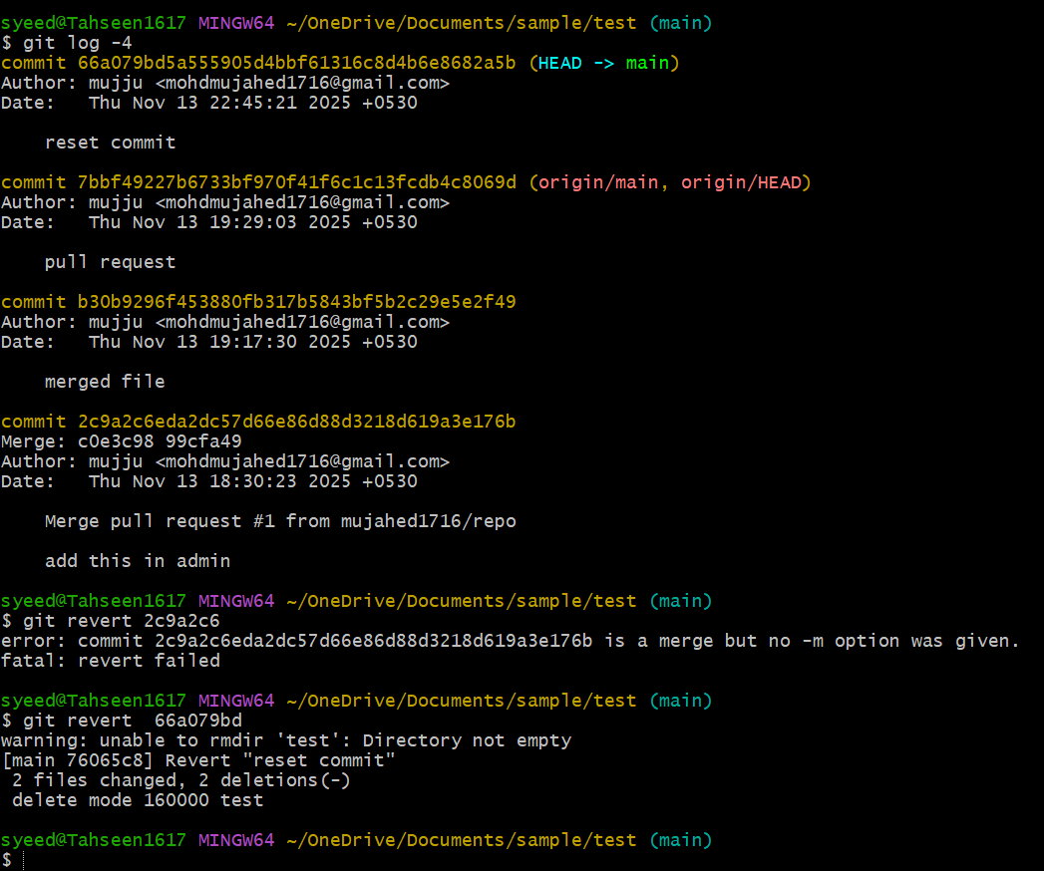

- Push a file to stash without savings the changes and work on another file.
- By using git stash command I have moved a file to temporary place and by using git stash list I have checked whether it is moved or not.

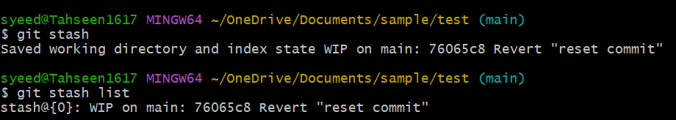

- Undo the stash file and start working on that again.
- By using git stash pop command I have moved the file from temporary location to main location to make changes.
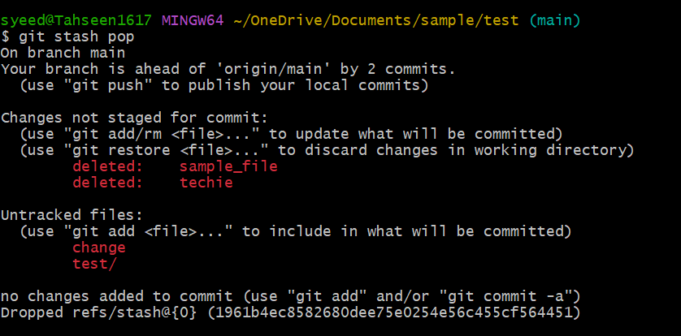

- Generate a ssh-keygen and configure into github.
- I have created a ssh key by using ssh-keygen command and pasted the public key in central repository.
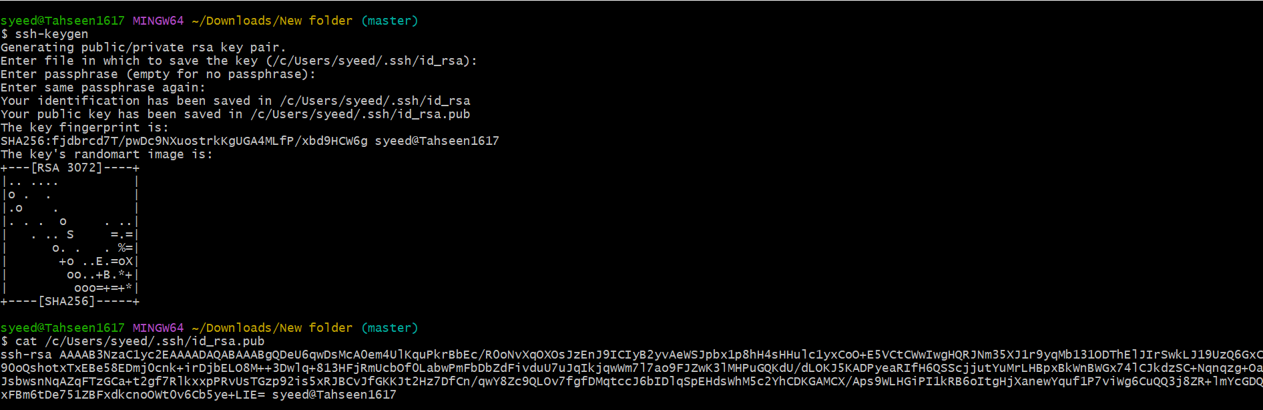

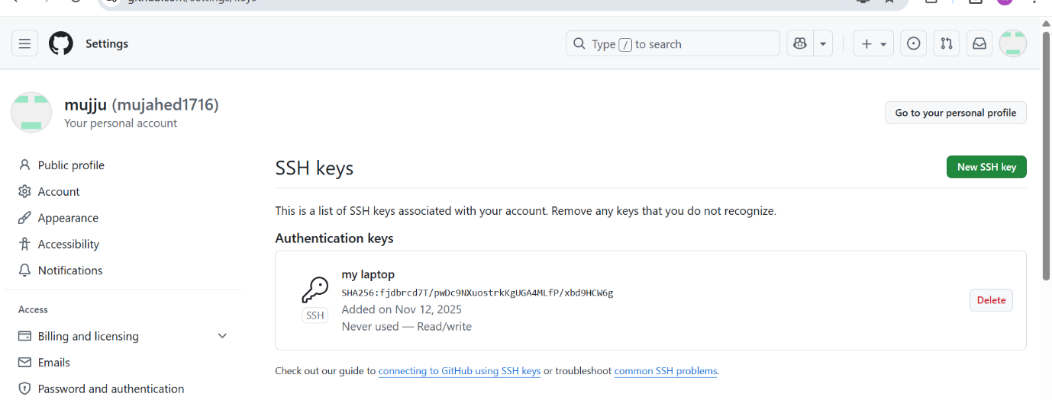

- Basic understanding of .git file.
When you run git init inside a project, Git creates a hidden folder called .git in your project directory.
“This. git folder is the heart of your Git repository”
What does the .git folder contain?
Here are the important parts (easy explanation):
- HEAD
- Points to the branch you are currently on.
- Example: refs/heads/main
- config
- Contains Git configuration for this repository.
- Example: username, email, remote URL
- refs/
- Stores references (pointers) to commits:
  - heads/ → branches
  - tags/ → tags
- objects/
- Most important folder
- Stores all Git data (commits, blobs/files, trees: the complete project history).
- index
- The staging area file.
- Stores what is ready to be committed.
- logs/
- History of operations like checkout, commit.

Why is the .git folder so important?
Because it stores the entire history of your project.
- If you delete the .git folder:
- Your project becomes a NORMAL folder
- All history is lost
- Git commands will stop working

19.Check all the logs of git.
- By using git log I have checked all the logs
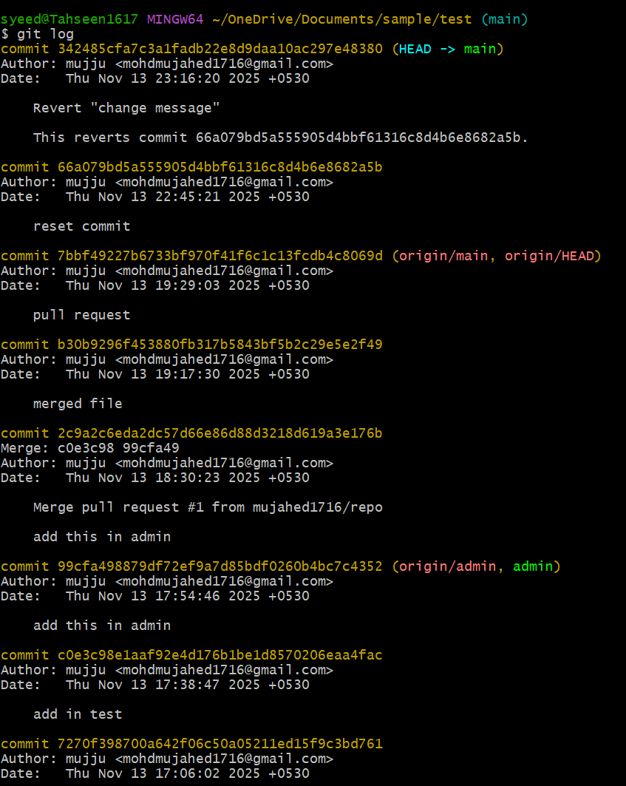

20.Rename the commit message.
- By using git commit –amend command I have changed the commit message.
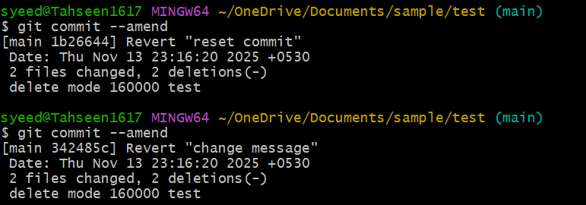

21.Merge multiple commits into single commit.
- By using git rebase -I Head~1 command I have made all the commits into single commit.
